Contributor name: XYZ
Book Proposed: BOOK_NAME
Total Chapters: 2
Total Examples: 10
Codable Examples: 8

Chapter 1: Introduction to probability
Example 1.1 – Codable
Example 1.2 – Non-Codable (Reason: Theoretical example with the purpose of proving a concept)
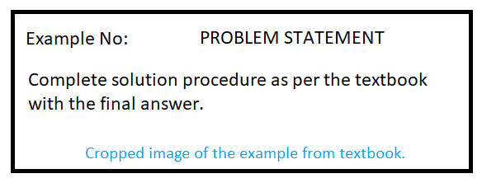
Example 1.3 – Codable

Chapter 2: Conditional probability
Example 2.1 – Codable
Example 2.2 – Codable
Example 2.3.1 – Codable
Example 2.3.2 – Codable
Example 2.4.1 – Codable
Example 2.4.2 – Codable
Example 2.4.3 – Non-Codable (Reason: Integration of variables has been performed resulting in a variable expression as the final solution)

