Summer Fellowship Report

On

Spoken Tutorials Creation Module

Submitted by

Mansi Gundre,
Pune Institute of Computer Technology, Pune

Under the guidance of

Prof.Kannan M. Moudgalya

Chemical Engineering Department

IIT Bombay

August 8, 2022

Acknowledgment

I, the FOSSEE intern of the Spoken-Tutorial Creation Module, is overwhelmed in all humbleness and gratefulness to acknowledge our deep gratitude to all those who have helped us put our ideas to perfection and have assigned tasks, well above the level of simplicity and into something concrete and unique
I wholeheartedly thank Nancy Ma’am for having faith in us, selecting us to be a part of his valuable project and for constantly motivating us to do better.
I am very thankful to our mentors Ankita Ma’am and Kirti Ma’am for their valuable suggestions. They were and are always there to show us the right track when needed help. With help of their brilliant guidance and encouragement, we all were able to complete our tasks properly and were up to the mark in all the tasks assigned. During the process, I got a chance to see the stronger side of our technical and non-technical aspects and also strengthen our concepts. Hereby, I gladly consider ourselves to be the most fortunate batch of interns.

Last but not the least, I wholeheartedly thank all our other colleagues working in different projects for helping us evolve better with their critical advice.

With Regards.

Mansi Gundre
(PICT Pune)

Contents

1. Introduction 4
1.1 Problem Statement 5
1.2 Problem Objective 5
1.3 Problem Outcome 5
1.4 Project Requirements 5
2. Project Overview: 7
2.1 Features 7
2.2 Technologies Used 8
3. Feature Implementation 9
3.1 Email Verification 9
3.2 Search Feature 9
1. A Search Bar Lets Users Find Things Faster 9
2. People Will Navigate Around and Stay On Your Site 10
3. Users are Used to a Search Function 10
4. You Can Use Your Search Analytics to Your Advantage 10
4. Tasks in detail 11
4.1 Email Verification 11
4.2 Search Feature 16
Steps Followed 16
4.3 Testing 18
5. Conclusion : 20
6. References : 21

1. Introduction

The Spoken Tutorial project is the initiative of the ‘Talk to a Teacher’ activity of the National Mission on Education through Information and Communication Technology (ICT), launched by the Ministry of Human Resources and Development, Government of India.
The use of spoken tutorials to popularise software development and its use will be coordinated through this website.
(The Spoken Tutorial project is being developed by IIT Bombay for MHRD, Government of India)
The Spoken Tutorial Project aims to make spoken tutorials on FOSS available in several Indian languages, for the learner to be able to learn in the language he/she is comfortable in. Our goal is to enable the use of spoken tutorials to teach in any Indian language, and to be taught to learners of all levels of expertise- Beginner, Intermediate or Advanced
This project is for the community and by the community. Through the portal, we aim to reach out to like-minded individuals to collaborate with us and with each other to create Spoken Tutorials. The next step is to get each Spoken Tutorial dubbed into as many Indian languages as possible. This will help anyone anywhere to understand the contents of the Spoken Tutorials. Each of the Tutorials, whether original or dubbed, go through a strict review procedure, after which they are uploaded on the public domain. This is to ensure that the highest possible quality is attained.

1.1 Problem Statement

- When A New User Register itself there has to be Email Verification.
- A Global Search bar in order to search a particular tutorial.
- Testing of the overall website.

1.2 Problem Objective
- For Security and transparency of user Email Verification is essential.
- A Global Search bar will provide a user-friendly interface to get the quick desired result.
- Testing of website in order to fix the present bugs.

1.3 Problem Outcome
Email Verification being and essential during registration to ensure that the registered email actually belongs to user will be implemented.

1.4 Project Requirements

- HTML : It is the main markup language for displaying web pages and other information that can be displayed in a web browser.

- CSS : (CSS) is a style sheet language used for describing the presentation semantics (the look and formatting) of a document written in a markup language.

- JavaScript : It is a prototype-based scripting language that is dynamic, weakly typed and has first-class functions and is mainly used for validation etc.

- Ajax : AJAX is the art of exchanging data with a server, and updating parts of a web page - without reloading the whole page.

- JQuery : It is a cross-browser JavaScript library designed to simplify the client-side scripting of HTML. It also includes the functionality of Ajax.

- Spring Boot : Java Spring Boot (Spring Boot) is a tool that makes developing web application and microservices with Spring Framework faster and easier through three core capabilities: Autoconfiguration. An opinionated approach to configuration

- Java : It is a general-purpose, class-based, object-oriented programming language designed for having lesser implementation dependencies.

- MySQL : It is the world's most used open source relational database management that runs as a server providing multi-user access to a number of databases.

2. Project Overview:
This series is created to empower Mothers, Fathers, Grandmothers, ASHAs, Auxiliary nurse midwives, Anganwadi workers and the entire community with the knowledge of life saving skills with the Maternal, Infant & Young Child feeding techniques.
And to also make them confident to impart the same training to their colleagues/ friends/neighbours and relatives and to caregivers of young infants and children.
Through this series the Spoken Tutorial project at IIT Bombay aims to reach out to scores of people for spreading awareness on Malnutrition and reduce infant mortality drastically in India and globally as well.
The tutorials will cover crucial topics and vital information that will help the entire community to easily understand and grasp the most important aspects or practical details of Breastfeeding, Complementary feeding and Pregnant & Lactating Mothers Nutrition.
The entire series will be created using simple words for ease of understanding and will be covered using graphics with simultaneous narration to help illustrate the respective topics with maximum clarity.
The outreach will be done using the translated and dubbed tutorials in all Indian languages that will cover the entire Indian landscape.

2.1 Features

- Tutorial for each Age Category: Tutorial for adolescent, adult, Kids being provided.

- Multiple Language Tutorial: Support Multiple regional Language which help to reach large audience .

- Filtering: Tutorial with markups being provided for category like Adolescent - Adult nutrition, Adult Nutrition, Breastfeeding, Complementary feeding, Growth charts etc is provided which can be filtered according to our requirements.

2.2 Technologies Used

- HTML : It is the main markup language for displaying web pages and other information that can be displayed in a web browser.

- CSS : (CSS) is a style sheet language used for describing the presentation semantics (the look and formatting) of a document written in a markup language.

- JavaScript : It is a prototype-based scripting language that is dynamic, weakly typed and has first-class functions and is mainly used for validation etc.

- Ajax : AJAX is the art of exchanging data with a server, and updating parts of a web page - without reloading the whole page.

- JQuery : It is a cross-browser JavaScript library designed to simplify the client-side scripting of HTML. It also includes the functionality of Ajax.

- Java : Java is a widely used object-oriented programming language and software platform that runs on billions of devices, including notebook computers, mobile devices, gaming consoles, medical devices and many others.

- Spring Boot : Java Spring Boot (Spring Boot) is a tool that makes developing web application and microservices with Spring Framework faster and easier through three core capabilities: Autoconfiguration. An opinionated approach to configuration. The ability to create standalone applications.
- MySQL : It is the world's most used open source relational database management that runs as a server providing multi-user access to a number of databases.

3. Feature Implementation

3.1 Email Verification

- Email verification helps prevent spam or fake users as only people with real emails are able to activate accounts after registration.
- Check and validate email addresses in real time to prevent bogus email registration. This helps maintain a clean and accurate email database of customers. By validating email addresses in real time , you can ensure you are only collecting real email addresses from real customers. This helps reduce CRM costs for unnecessary contacts and improve email marketing performance
- Once a user submitted the signup form, a verification code is generated and sent to his email, and he must open that email and click on the verification hyperlink to activate the account. Then the user will be able to login.

3.2 Search Feature
There can be many Categories, Topics, Languages in the database, so we want to add a search function that helps the users to easily find products based on a specific keyword.

We have to filter data using the thymeleaf template and Spring data JPA.
Why Search Feature is important?

1. A Search Bar Lets Users Find Things Faster
If you have a large site, a search bar allows your users to find what they’re looking for quickly.
Considering the present tutorial website it is difficult to scroll over all the options available just to one, So think of search as a way for users to escape when they are stuck in your navigation. If they can’t find a reasonable place to go next, they’ll turn to your search function.
No matter where each user enters your site, a search bar will give them the option to find particular topics or pages fast. Just make sure that the search bar is easy to find.

2. People Will Navigate Around and Stay On Your Site
Think about it: the easier it is for users to navigate around your whole website, the more likely it is that they will explore it. If it’s not easy for them to find what they’re searching for, they will go somewhere else that can satisfy their needs.
You can measure this by looking at the time on site or average pages per session in Google Analytics. This is a loose reflection of how engaging and relevant your site’s content is to people. Give users the opportunity to see as much of your website as possible with a search bar!

3. Users are Used to a Search Function
Google and other search engines have changed the way we learn information and consume it quickly. A search bar on your site will serve as your site’s own personal “search engine,” which most people are accustomed to nowadays. People look for things within Google—so let them do the same within the content of your site.

4. You Can Use Your Search Analytics to Your Advantage
If you can integrate your search bar into your Google Analytics, you’ll be able to see how often people search for a particular term. This information can be used for your advantage to modify your page content, hierarchy, or design.

4. Tasks in detail
Task | Status
Email Verification during registration | ✅
Search Feature | Partially Done
Testing | ✅

4.1 Email Verification
How Email verification Works :
- Add two fields verification code and enable .
- Verification code will store a random, unique string which is generated in the registration process and will be used in the verification process.
- Enabled will return either true or false.
- Using JavaMail to send mail.
- Implement User Account Verification Functionality.
- Test User Registration Verification Email.

After successful registration Mail will come on registered mail id.

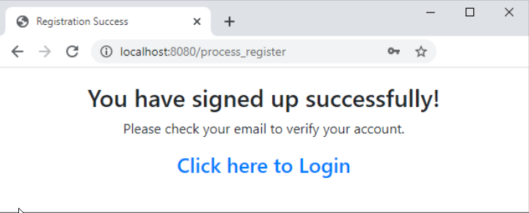

Now Before logging in Go to mail and click on the verify link that was sent.

If verified Successfully registered message is displayed.

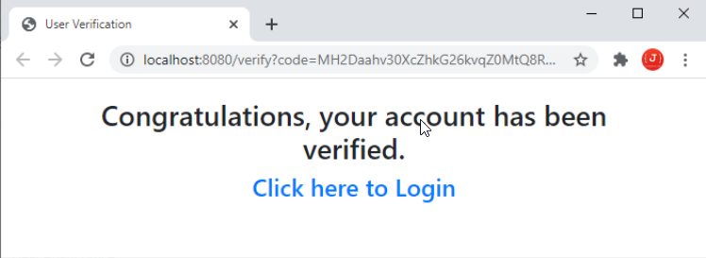

Validation done if user already exists or has already been verified

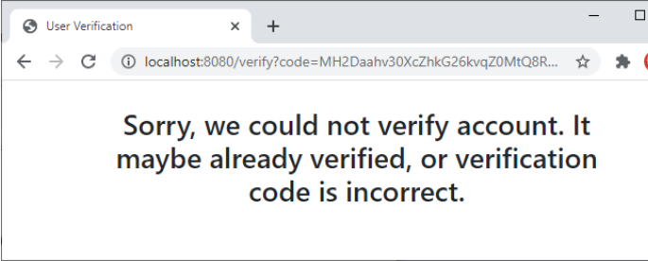

Verify route :

Render verify_success page if successfully registered and verify_fail if verification fails.

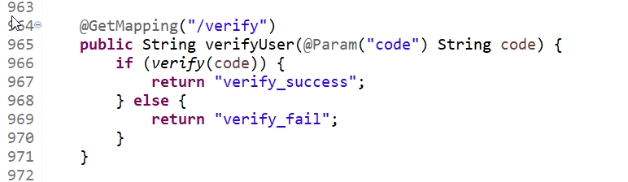

Mail Send Template Code:
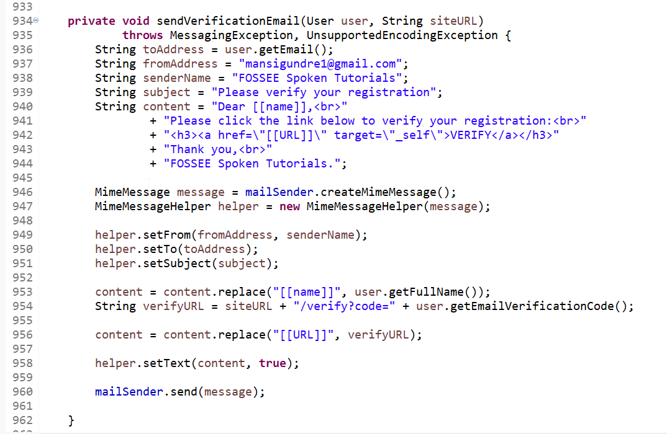

Mail Send on registered email

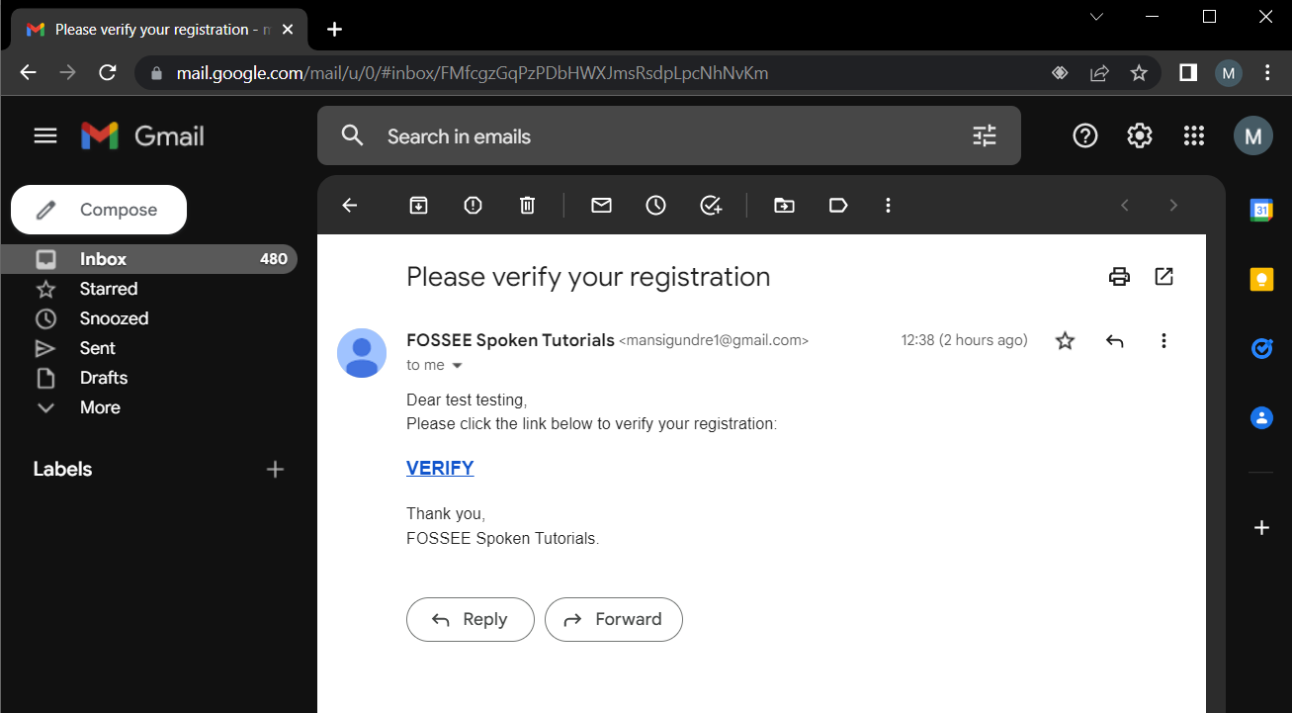

Validation done if user already exists

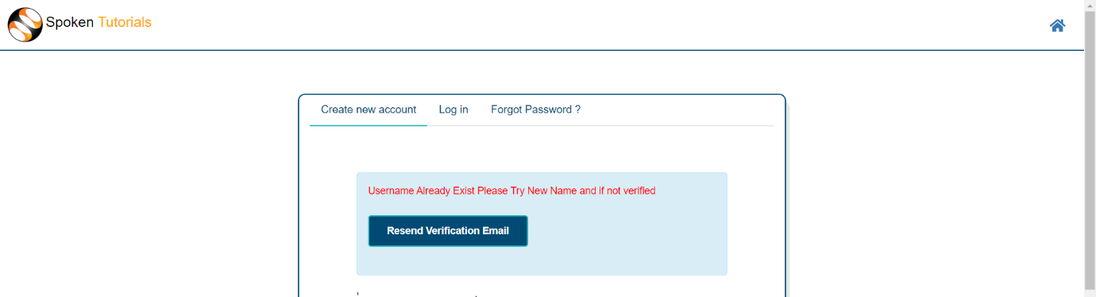

4.2 Search Feature

Steps Followed
- Build a search query. (
"SELECT p FROM Category p WHERE p.name LIKE %?1%"
+ " OR p.category LIKE %?1%"
+ " OR p.language LIKE %?1%"
+ " OR CONCAT(p.category, '') LIKE %?1%"
)
- Update Service and Controller
- Create code search form using Thymeleaf

This feature is statically implemented only to search categories.

Search Bar

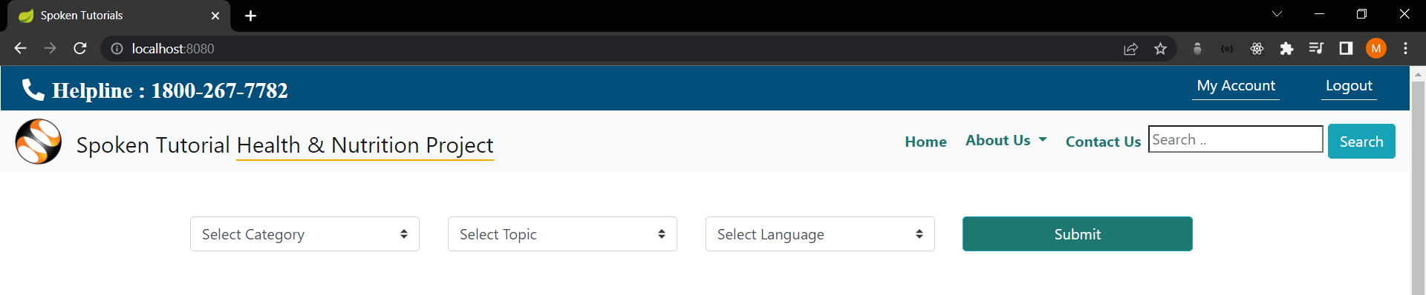

Result for adolescent keyword :

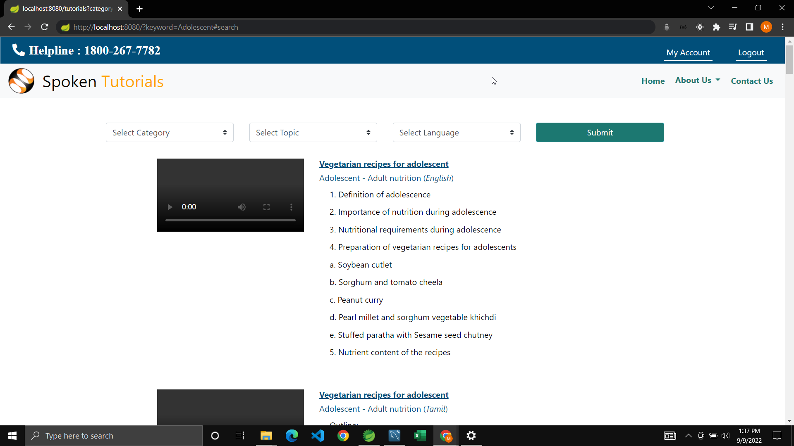

4.3 Testing

Testing was done for permutation and combination of tutorials being provided by spoken tutorial .

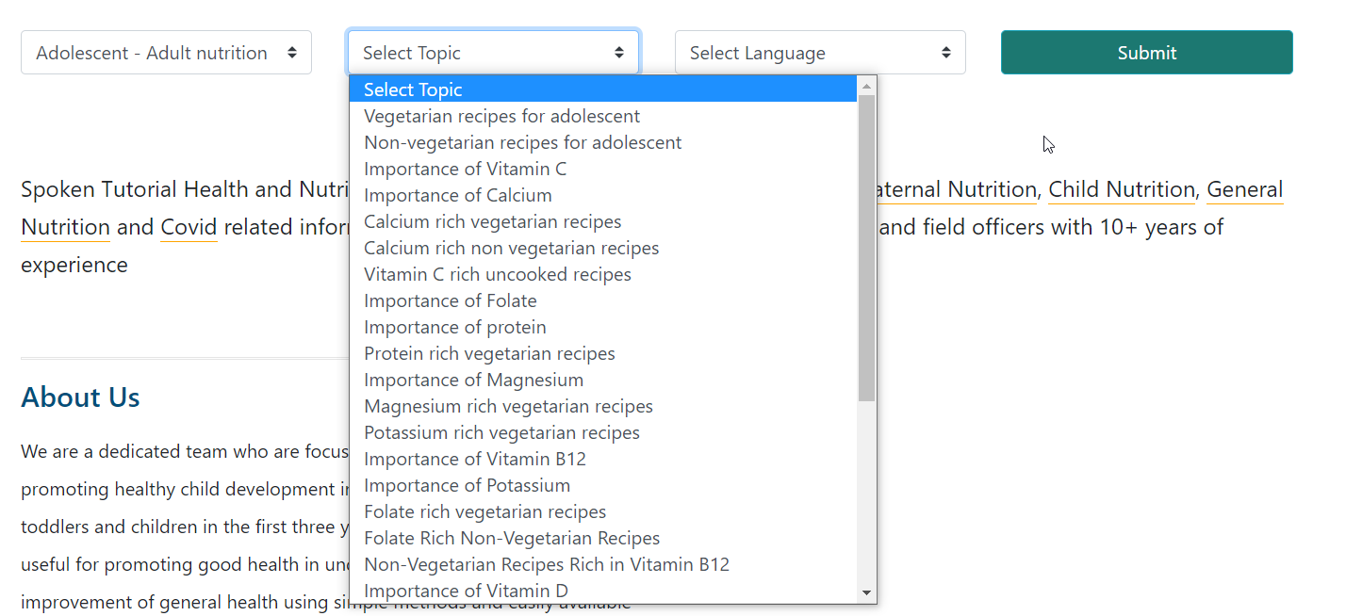

These Combinations included Category name, topic name, and the language.
About 45+ test cases were tested and its detailed report was made.

Objective:
- Finding defects which may get created by the programmer while developing the software.
- Gaining confidence in and providing information about the level of quality.
- To prevent defects.
- To make sure that the end result meets user requirements.
- To gain the confidence of the customers by providing them a quality product.

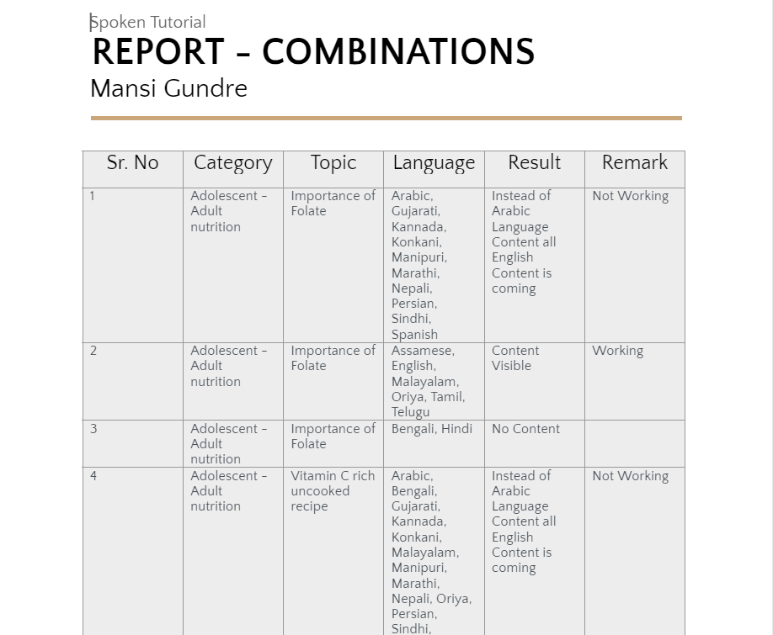

A report was made on the tested combination present on live website
Report Link: https://docs.google.com/document/d/1EPrS1rFBvaGUxAo_jjp6X5UClRZAYlycWSGhbxuYBbY/edit?usp=sharing

5. Conclusion :
In Conclusion, I have successfully implemented email verification , Static Search Operation for Categories and testing of the overall website. This will help improve security of the user registering for the tutorial.

6. References :
- Email Verification: https://www.codejava.net/frameworks/spring-boot/email-verification-example
- Search Operation: https://www.codejava.net/frameworks/spring-boot/spring-data-jpa-filter-search-examples

