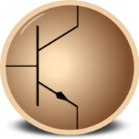
Circuit Simulation Project
https://esim.fossee.in/circuit-simulation-project

Name of the participant :

Title of the circuit :

Theory/Description :

Circuit Diagram(s) :

Results (Input, Output waveforms and/or Multimeter readings) :

Source/Reference(s) :

