Flowsheet Title

Contributor Name
Institute

Background & Description:

Flowsheet:

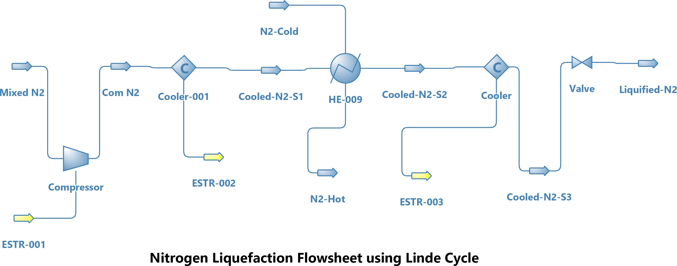

Results:
Results table here

